DESIGN AND IMPLEMENTATION OF A WEB-BASED CAR RENTAL SYSTEM

BY

ADETONA-IBRAHIM TOLUWALASHE

16CH021474

A PROJECT SUBMITTED TO THE DEPARTMENT OF COMPUTER AND INFORMATION SCIENCES, COLLEGE OF SCIENCE AND TECHNOLOGY, COVENANT UNIVERSITY OTA, OGUN STATE.

IN PARTIAL FULFILLMENT OF THE REQUIREMENTS FOR THE AWARD OF THE BACHELOR OF SCIENCE (B.Sc.) Honors DEGREE IN MANAGEMENT INFORMATION SYSTEMS

SEPTEMBER 2020

**CERTIFICATION**

I hereby certify that this project, was carried out by Adetona-Ibrahim Toluwalashe in the Department of Computer and Information Sciences, College of Science and Technology, Covenant University Ota, Ogun State, Nigeria, under my supervision.

1. Name: MR. JESSE OLUWAFEMI KATENDE

(**Supervisor)**

Signature: ­____________________ Date: ­­­­­­­­­­­­­­­­­­______________________

1. Name: Prof. Ambrose A. Azeta

(**Head of Department)**

Signature: ____________________ Date: ______________________

**DEDICATION**

I dedicate this work to GOD Almighty, my source of inspiration, understanding, and knowledge. I also want to dedicate this work to my Mother Mrs. Adetona-Ibrahim Aderinola, my source of encouragement throughout my 4 years of study and also to the memory of my Father Mr. Adetona-Ibrahim Abdulrazaq who instilled in me all the values and lessons that made me who I am today.

**ACKNOWLEDGEMENT**

My sincere gratitude goes to the Almighty God for his grace and mercy throughout the course of this project, I also thank Him for blessing me with the spirit of wisdom and understanding and also granting me strength to be able to finish this project without complications.

I also want to thank my parents, Mrs. Aderinola-ibrahim and Late Mr. Adetona-Ibrahim for their prayers, motivation, enduring love and support throughout my 4 years in Covenant University for without them I won’t be where I am today.

I also want to thank my supervisor Mr. Jesse Oluwafemi Katende for his patience, guidance and encouragement for without him, this project would have not been a success.

I also want to thank everyone else who had a part in making this project a success.

**TABLE OF CONTENT**

Title Page

Certification i

Dedication ii

Acknowledgment iii

Table of Contents iv

List of Tables vii

List of Figures viii

Abstract ix

**CHAPTER ONE: INTRODUCTION**

1.1 Background of the Study 1

1.2 Statement of the Problem 1

1.3 Aim and Objectives of the Study 2

1.4 Research Methodology 2

1.5 Significance of the Study 3

1.6 Limitation of the Study 3

1.7 Research Outline 3

**CHAPTER TWO: LITERATURE REVIEW**

2.1 Information Systems 4

2.1.1 Components of an Information System 4

2.1.2 Importance of Information Systems 5

2.1.3 The Information Processing Cycle 5

2.1.4 Types of Information Systems and Their Functions 5

2.1.5 Advantages of Information Systems 6

2.1.6 Disadvantages of Information Systems 6

2.2 History of Car Rental 6

2.3 Car Rental System Approaches 7

2.3.1 Manual Approach 7

2.3.1.1 Advantages of Manual Approach 7

2.3.1.2 Disadvantages of Manual Approach 8

2.3.2 Web-Based Approach 8

2.3.2.1 Advantages of Web-Based Approach 8

2.3.2.2 Disadvantages of Web-Based Approach 8

2.4 Review of Existing Systems 8

2.4.1 Alamo Rent a Car 9

2.4.2 Avis Car Rental 9

2.4.3 I-Go Rentals 10

2.4.4 Gata Transport 11

**CHAPTER THREE: SYSTEMS ANALYSIS AND DESIGN**

3.1 Introduction 12

3.2 System Analysis 12

3.2.1 Functional Requirements 12

3.2.2 Non-Functional Requirements 13

3.3 System Design 13

3.3.1 System Modelling 14

3.3.2 Unified Modelling Language 14

3.3.2.1 Use Case Diagram 14

3.3.2.2 Sequence Diagram 16

3.3.2.3 Activity Diagram 17

3.3.2.4 Class Diagram 19

3.4 Database Design 20

3.4.1 Description of Tables 21

**CHAPTER FOUR: SYSTEM IMPLEMENTATION**

4.1 Introduction 23

4.2 System Requirements 23

4.2.1 Hardware Requirements 23

4.2.2 Software Requirements 24

4.3 Implementation Tools Used 24

4.4 Software Development Methodology 24

4.5 Program Modules and Interfaces 26

4.5.1 Login Module 26

4.5.2 Registration Module 26

4.5.3 Reservation Page 27

4.5.4 Home Page 28

4.5.5 System Report (Admin) 28

4.5.6 Car Listing Page 29

4.5.7 User Profile Page 30

**CHAPTER FIVE: SUMMARY, CONCLUSION AND RECOMMENDATION**

5.1 Summary 31

5.2 Conclusion 31

5.3 Recommendations 32

References 33

**LIST OF TABLES**

Table 3.1: Use Case- Reserve Vehicle 16

Table 3.2: User Table 21

Table 3.3: Admin Table 21

Table 3.4: Booking Table 21

Table 3.5: Vehicle Table 22

Table 4.1: The Hardware Requirements 23

Table 4.2: Software Requirements 24

**LIST OF FIGURES**

Figure 2.1: Alamo rent a car 9

Figure 2.2: Avis car rental 10

Figure 2.3: I-GO rentals 10

Figure 2.4: Gata Transport 11

Figure 3.1: Admin Use Case Diagram 15

Figure 3.2: Customer Use Case Diagram 15

Figure 3.3: Sequence Diagram- Vehicle Reservation 17

Figure 3.4: Activity Diagram – View Vehicle 18

Figure 3.5: Activity Diagram - Add Vehicle 18

Figure 3.6: Activity Diagram – User Login 19

Figure 3.7: Class Diagram for Car Rental System 20

Figure 4.1: Agile Development Process 25

Figure 4.2: Login Module 26

Figure 4.3: Registration Module 27

Figure 4.4: Reservation Page 27

Figure 4.5: Home Page 28

Figure 4.6: System Report (Admin) 29

Figure 4.7: Car Listing Page 29

Figure 4.8: User Profile page 30

**ABSTRACT**

Rental companies are companies that provide a particular rental unit to the customer for a while in which the customer pays for the time he/she is going to use the unit. It relieves the customer of the costs accompanying the ownership and maintenance of the unit. A car rental company is a company that provides car rental services for a short time for a stipulated fee that accumulates depending on the number of days the car is rented.

In Nigeria, the renting process is still manual which is cumbersome, customers have to manually fill out the required forms, then submit to the office physically before verification begins and the car is handed over to the customer. This project solves this problem through the creation of a web-based car rental system which streamlines the activities of the user and agency.

**CHAPTER ONE**

**INTRODUCTION**

* 1. **BACKGROUND OF STUDY**

Information systems are organized systems that collect, organize, store and communicate information. It is the study of complementary hardware and software networks used by people to collect, process, create and distribute data. An information system can also be defined as a blend of hardware, software, information and business processes which can be utilized to increase the proficiency and administration power of an organization. The car rental system is an example of an information system (Bourgeois, 2014).

Car renting dates from 1904. In 1912 the German company SIXT was formed under the name Sixt Autofahrten und Selbstfahrer (SIXT Car Cruises and Self Drivers) (Wikipedia contributors, 2019). The leasing process was manual and cumbersome, customers had to manually fill out the required forms, then submit to the office physically before verification begins and the car is handed over to the customer, the agencies had to keep records manually which is not reliable and can be subject to loss due to many factors.

This project is intended for use by any Car Rental service that wants to upgrade to a web based system. A car rental or vehicle hire business enterprise is an organization that rents cars for short periods for a price which is determined by the amount of days or hours the car is to be used. Car rental companies serve individuals in need of vehicle for temporarily use. For instance, individuals that do nott personally own vehicles/ individuals whose vehicles are temporarily out of use/ services and are anticipating repair. Car rental agencies may additionally serve others in the moving industry, by leasing trucks or vans, also one-of-a-kind sorts of vehicles may be made available e.g. bikes, scooters (Wikipedia, 2019).

This system gives users the ability to see available vehicles for rent, Register, update profiles and book available vehicles. It enables the car rental agency advertise and make available their services to people through internet services. It also helps the agency keep comprehensive records on their customers and vehicles.

* 1. **STATEMENT OF THE PROBLEM**

Most car rental agencies in Nigeria still use the manual process to go about their businesses which is riddled with problems which include the following: risk of information loss due to the use of physical storage, services offered are limited to working hours therefore customers have limited time to book cars, limited customer reach and inefficiency due to manual recording and retrieval of information (Ibrahim, 2020).

To this end, the creation of a Web-based car rental system is necessary.

* 1. **AIM AND OBJECTIVES OF STUDY**

The project aim to develop a web-based Car Rental system that would be used by customers to easily rent cars and also by renting companies to streamline their manual processes.

The objectives of the work include:

1. Studying existing car rental systems.
2. Using the Knowledge gotten from reviewing existing systems to formulate requirements for the proposed system.
3. Designing and modelling a web-based car rental system based on the gathered requirements.
4. Implementing a web-based car rental system that can be easily used to book vehicles and manage vehicles and user information.
   1. **RESEARCH METHODOLOGY**

The research methodology explains the best method to be used to achieve the listed objectives. It describes the systematic ways /procedures used to develop the project.

**Objective 1: Studying existing car rentals systems**

1. Involves studying various car rental systems in order to deduce requirements for the new system.

**Objective 2: Using the knowledge gotten from reviewing existing systems to gather requirements for proposed system.**

Using the knowledge retrieved from analyzing the existing systems and literatures, the functional and non-functional requirements for the system will be identified.

**Objective 3: Design and model a web-based car rental system based on the requirements.**

Involves the use of UML diagrams: Class, Use-case, Activity and Sequence to model and design the system according to the requirements.

**Objective 4:** **Implementing a web-based car rental system used to book vehicles, store and retrieve vehicle and user information.**

1. Sublime Text 3 is used as the development environment of the website.
2. HTML, JAVASCRIPT and CSS are used to develop the Front-End of the system.
3. PHP is used to build the functionality of the server-side.
4. MYSQL is the database used.
   1. **SIGNIFICANCE OF THE STUDY**

This project will provide solutions to the various issues related to the manual car rental process.

1. Wastage of valuable time will be worn out which will in turn increase the profitability and efficiency of the agency.
2. It enables the company to offer its services seamlessly to anyone around the world provided that an internet connection is available.
3. It provides a means of direct communication between the customer and the agency, increasing customer retention.
4. It provides a safe, secure and fast way to store and retrieve information and also manage vehicles.
   1. **LIMITATION OF THE STUDY**

The proposed system does not support the tracking of vehicles and the customer must have an internet connection to allow them to use the system.

* 1. **RESEARCH OUTLINE**

This research is outlined in this order, Chapter one contains a general introduction, the problem statement, the aim and objectives of the work, the project’s significance, the methodology used and the limitations of the project. The second chapter contains a critical review of existing literature and systems related to Car rental systems. The Third chapter describes the analysis and design of the system. Chapter Four presents the system implementation, it contains screenshots of the system when implemented. Chapter Five shows the results of the system, the conclusion, summary and further recommendations.

**CHAPTER TWO**

**LITERATURE REVIEW**

**2.1 INFORMATION SYSTEMS**

Information systems are series of human and technological assets that provide information required by the user for storing, processing, dissemination and communication. An example of an information system is the management information system ([MIS](https://searchitoperations.techtarget.com/definition/MIS-management-information-systems)), which provides management information for organizations. An information system can also be defined as components that combine resources aimed at processing data and information. Information systems are also used to collect, organize and store information.

They can also be described as combining human resources, infrastructure, applications, communication networks, computer services, and policies which increases the efficiency, effectiveness and overall management of an organization. The word Information Systems is an expression that describes Automated Systems covering people, which helps in the collection, processing, and transmission of data representing information for the client.

**2.1.1 Components of an information system**

Information systems are made up of five (5) components:

* Hardware – They consist of the Physical equipment used for input, output and processing. They include: input and output devices, processors, OS and media devices.
* Software – These are programs used in controlling the various hardware components.
* Database - Data can be defined as raw facts that is unorganized and processed to generate information. Databases consists of organized data in the right structure.
* Network – Network services apply to the intranet, extranet, internet, networking channels, hubs and network devices.
* People – Consists of the manpower needed to run and manage the system. They include the consumers (end-users), network administrators, system specialists, etc.

**2.1.2 Importance of information systems**

1. Allows businesses make smarter decision with less time and money.
2. It reduces Human Error.
3. It boosts the efficiency and productivity of the organization.
4. It gives the organization complete control over its information.

**2.1.3 The information processing cycle**

Data must pass through these stages below before it can be successfully transformed into useful information.

* Input – This phase involves the collection of information by the computer through input sources e.g. keyboard, mouse, microphones, etc.
* Processing – Once the system has received the data, the computer performs a series of operations specified by the user or the program.
* Output- The processed data is now provided to the user as information through display on the monitor, printers or speakers as sound.
* Storage – After the process, the system stores the information for future use by the user or program.

**2.1.4 Types of information systems and their functions**

There are many information systems with various functions, below are some of the systems.

1. Transaction Processing Systems – It operates at an organizations’ operational level. This system retrieves and stores transaction information and controls some parts of the transactions. The data collected is normally stored in databases which can later be used to generate reports.
2. Management Information System – It operates at the management level of organizations. It transforms the data gotten from the transaction processing system into information for performance monitoring and management purposes. It collects information from the transaction processing system then proceeds to create the appropriate reports.
3. Decision-support Systems - analyzes data to enable users make informed decisions.
4. Expert Systems – aka Knowledge based systems is designed to analyze data and recommend decisions and actions in a controlled manner.

**2.1.5 Advantages of information systems**

* With IT, communication is more efficient and cheaper
* Availability; organizations can now offer their services 24/7 all over the globe. Organization can offer their services to individuals in different parts of the world without having to meet them physically
* Creation of new jobs types; Information systems have made new jobs available, the need for programmers, system analysts and developers are needed due to the nature of the systems

**2.1.6 Disadvantages of information systems**

* Security; Hackers can now access sensitive information of organizations with weak security infrastructures and sell the information to buyers online.
* Implementation Costs; before the system is up and running, the organization must train staff how to use the system, buy hardware’s and in some cases rent services.
* Unemployment; the integration of information systems have streamlined many organizational operations, therefore the need for human resources may no longer be needed. E.g. the use of telephone answering systems have replaced the need for human receptionists.

**2.2 HISTORY OF CAR RENTAL**

A car hire or car rental agency is a company that leases vehicles for brief intervals of time, varying from a few hours to a few weeks. Often it is organized with several local [branches](https://en.wikipedia.org/wiki/Branch#Organizations) which enable the user to return the vehicle to a different location. They are primarily located near [airports](https://en.wikipedia.org/wiki/Airport) or busy areas in the city and often accompanied by an internet site which allows online [reservations](https://en.wikipedia.org/wiki/Computer_reservations_system) (Wikipedia contributors, 2019).

Car rental can be traced to 1904, it started when a bike shop started putting cars up for rent. The year 1912 brought about the establishment of a German company Sixt, which started with only three cars up for rent then quickly expanded. Car rentals in the U.S started in 1915, when Joe Saunders a man from Nebraska lent his car to local and visiting tourists or businessmen (Arnold Clark car and van rentals, 2015). He attached a mileage meter to his car, charging the renters 10 cents per mile covered so as to cover any wear on his car, he then realized this was a lucrative business and by 1925, 10 years later his independent car rental company had expanded to 21 states with an estimate of over 1million dollars’ worth of Chrysler vehicles. By 1923 a new competitor entered the market in the form of Walter L Jacobs and the business quickly grew to surpass his expectations bringing in a whopping 1 million dollars in annual sales with just a dozen of his personal model T fords making him Saunders’ main competitor (Paul, 2011). In the 21st century, car rental companies have grown rapidly all over the world to meet the increase in demand. As the world globalizes, people travel at growing rates and hire cars, vans and other vehicles more often than ever (Arnold Clark car and van rentals, 2015).

In the Mid 1920’s Mr. Walter L Jacobs sold his business to Mr. John Hertz, the owner of a company that specializes in manufacturing yellow cabs giving birth to one of the largest rental companies in the nation. The company was later bought by General motors and renamed “Hertz Drive-Ur-Self System” (Paul, 2011).

Today's rental of cars is not confined to daily activities, people also rent cars for short and long periods, for those who do not own cars and need to use one. There are various reasons for renting cars; e.g. individuals not wanting to put wear on their own cars, size; the individual’s car may not serve the purpose he/she wants to achieve. Furthermore, people travel and don’t carry their cars, therefore they rent cars to enable them go about their activities in their destinations. Another reason people rent cars is for moving purposes, rental companies rent vans and trucks to movers due to the large amounts of space the trucks or vans provide (Essays, UK, 2018).

**2.3 CAR RENTAL SYSTEM APPROACHES**

1. Manual Approach
2. Computerized approach

**2.3.1 MANUAL APPROACH**

All the operations of the system are manual meaning it requires human beings to conduct all the operations without the use of any information system. Transactions are written in journals/registers and manually transformed in statements.

**2.3.1.1 Advantages of manual approach**

1. Computer Literacy is not needed
2. No Internet connection is needed.

**2.3.1.2 Disadvantages of manual approach**

1. Wastage of time and resources – All the processes are done manually which increases the amount of time used to complete them and in order to capture or store information, large amounts of paper are used which can be prevented through the computerized system.
2. Physical Storage of user or company information which can be destroyed by human or natural occurrences
3. There’s no avenue to convey information to customers except physically and for customer to provide feedback.

**2.3.2 Computerized approach**

This system is the combination of both software and hardware resources designed to work without human intervention.

**2.3.2.1 Advantages of Computerized approach**

1. Efficiency – It streamlines the rental process therefore increasing efficiency.
2. Reliable storage functionality - Provides easier and faster access to information.
3. Accessibility – Services are always available to the users as long as the user has an internet connection
4. Scalability – The system can be upgraded to accommodate the company’s future needs.

**2.3.2.2 Disadvantages of Computerized approach**

1. Due to its connection to the internet, it may be vulnerable to attacks from hackers.
2. Basic knowledge of computer use needed.
3. The system can’t be accessed without an internet connection.
4. Data is held on a server, therefore if the server database is damaged, it may lead to loss of information.

**2.4 REVIEW OF EXISTING SYSTEMS**

This section reviews the various existing car rental systems.

**2.4.1 Alamo rent a car**

North America’s largest car rental service, Alamo provides a range of services to visiting foreigners. It is an internationally recognized value-oriented brand that serves the rental needs of airport leisure travelers. They offer low rental rates plus a stress free customer experience in all the most popular travel destinations throughout the US, Mexico, Canada, Asia, the Caribbean and Latin America. Alamo offers self-serve kiosks located at major points in the U.S. airport allowing customers to speed up their check-in time and hit the road faster. Alamo’s best rates are offered to customers who book online, they are also entitled to additional discounts if the “Prepay & Save” option is chosen during the online reservation process. (Alamo rent a car, n.d.). Fig 2.1. Below is a screenshot of Alamo’s check- in page.

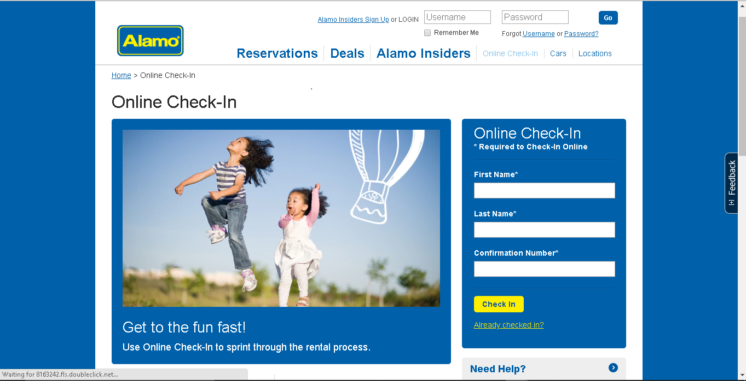

Fig 2.1. Alamo Online check in

Source: <https://www.alamo.com/en_US/car-rental/checkin.html>

**2.4.2 Avis car rental**

Owned by Avis Budget Group, avis car rental is one of the world's best-known brands in the car rental industry with around 5,500 locations in more than 165 countries. The company is known for their innovation in the car rental industry as well as being amongst the top brands for loyalty to customers in the world.

They provide a wide range of services, products, protection and coverage’s, e.g. fuel plans. GPS navigation, child safety seats if needed, emergency sickness plans, personal accident insurance and additional liability insurance packages (Avis car rental, n.d.).

Fig 2.2. Below is a screenshot of the Avis booking page.

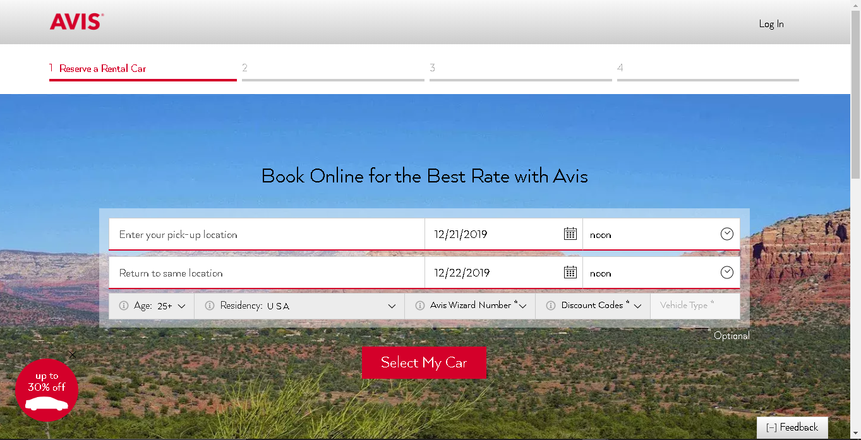

Fig 2.2. Avis Booking Page.

Source: [www.avis.com/en/reservation/make-reservation](http://www.avis.com/en/reservation/make-reservation)

**2.4.3 I-GO rentals**

I-GO Rentals in Platis Gialos of Mykonos has a large selection of rental cars suitable for a wide range of needs. For business travelers or holidaymakers that can enjoy the greatest possible mobility and flexibility during their stay in the Cycladic capital. They provide rental services to value-conscious travelers.

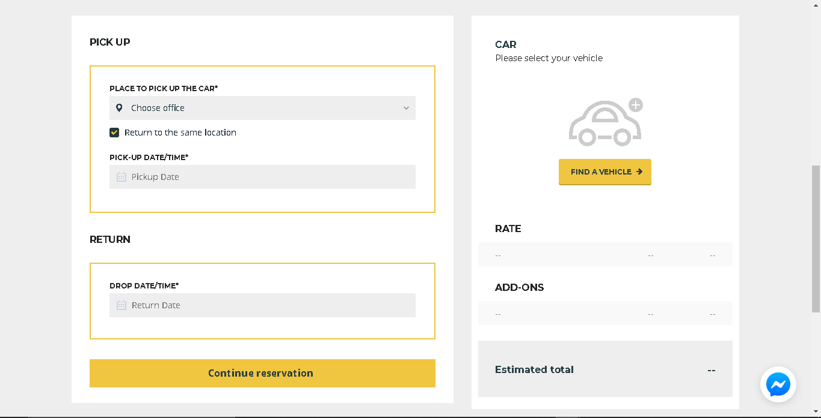They offer a wide range of services which include but are not limited to: 24 hour assistance, yacht renting, helicopter renting, chauffer services, car delivery services, online booking (I-Go rentals, n.d.). Fig 2.3. Below show a screenshot of the Reservation page of I-GO rentals.

Fig.2.3. Reservation page for I-GO Rentals

Source: <https://i-gorentals.com/date-reservation/>

**2.4.4 Gata Transport**

Gata transport is a Nigerian fast-growing investment and digital transport company. They boast of having the best alternative to everyday commuting and logistics made possible with a strong network of high technology solutions which makes transportation accessible while also being affordable. Asides Vehicle hire, they also provide logistics and travel services. Fig. 2.4 below is a screenshot of the Gata transport reservation page.

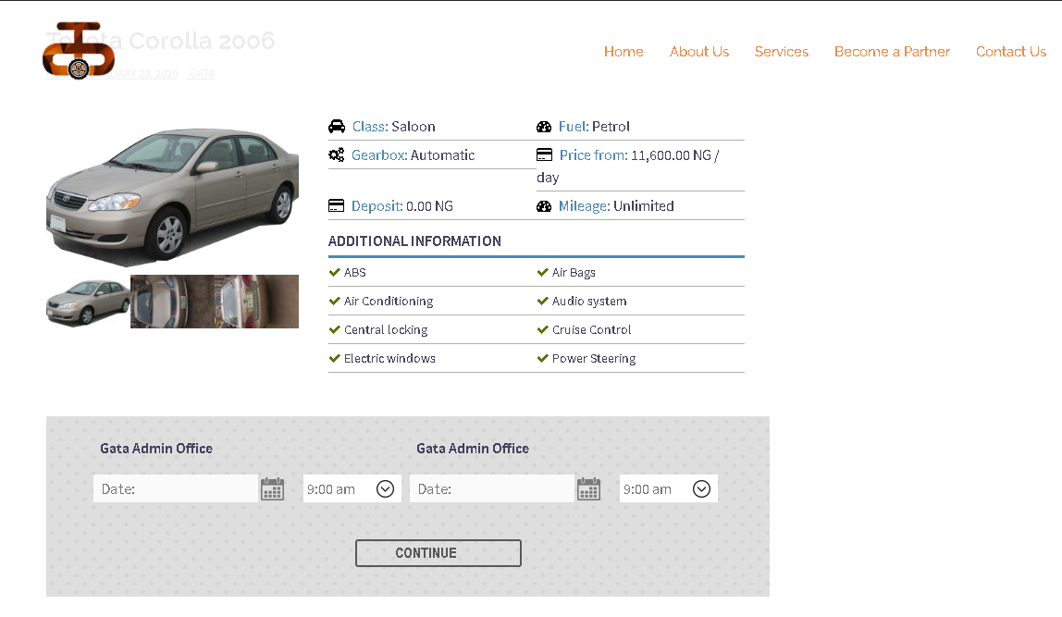

Fig 2.4 Gata Transport Reservation page

Source: <https://gatatransport.com.ng/vehicle-hire/>

**CHAPTER THREE**

**SYSTEMS ANALYSIS AND DESIGN**

**3.1. INTRODUCTION**

Systems are unified sets of procedures, routines, elements, or specific methods formulated to perform specific actions/achieve a goal. A system is comprised of three major components: input, processing, and output; it collects input from the environment, which goes through a transformation process that is provided to the user as output.

Systems development consists of the following processes: the planning, analysis, design, implementation, and maintenance phases, but this chapter, the focuses on the analysis and design of the car rental system.

**3.2. SYSTEM ANALYSIS**

This is the dissection of a system into its different components aimed at studying how well the different components interact with each other to achieve the desired goal. In this chapter, the proposed system is analyzed completely, depicting user roles processes and actions.

**3.2.1. Functional requirements**

These are requirements that show the inner working nature of the system, describe the system and its subsystems. It consists of if the various tasks the system should perform, the interfaces with the user, the data the system should hold, and the processes involved. It states the system's services and how it should react to specific inputs and its behavior in different situations.

The functional requirements of the system are:

1. The customer should be able to register and login.
2. The customer should be able to change his/her password.
3. The customer should be able to view available cars and book a car.
4. The customer should be able to give feedback and post testimonials.
5. The system automatically should store details of new customers and reservation information without the admin’s intervention.
6. System administration activities should be carried out only when admin logs in.
7. The admin should be able to add and delete cars and also update car information.
8. The admin should be able to either accept or decline reservation requests.
9. The admin should be able to login and change password.
10. The admin should be able to manage customer information and testimonials.

**3.2.2. Non-Functional Requirements**

Non-Functional requirements (NFR) are requirements that define parameters that can be used instead of actual actions to determine the performance of a program. It is also used to judge the operation of a system, rather than specific behaviors. They also define system attributes such as security, usability, performance, maintainability, reliability, and scalability. The system as a whole is often subject to non-functional requirements, and they do not exclusively apply to individual system features or services. The quality attributes are often called non-functional requirements.

The Non-Functional requirements include:

1. Security: The system should validate all users of the system before allowing access. This provides information integrity due to the fact that the system would not concede access to unauthorized users.
2. Availability: The system being online would be available for use always. There is no time constraint on the uptime of the system.
3. Performance: The system ought to provide results rapidly without taking a great deal of memory space on the client’s PC, and should not make any mistakes.
4. Usability: The Different modules of the system are consistent, making the system very easy to use.
5. Privacy: This system will not disclose, trade the personal information to any third party, and every data collected via analytics and will be solely used for in-house evaluation of the system.
6. Reliability: All data used by the system is stored in a well-built database schema; therefore, there is no risk of data loss.

**3.3. SYSTEM DESIGN**

System Design is a systematic approach to the design of a system using either a top-down or bottom-up method. Nevertheless, this is a systematic process therefore it takes into consideration all associated variables of the device that needs to be made out of the structure, to the desired hardware and software program, right down to the information, and the way it travels and transforms for the duration of its travel via the system (Jansen, 2015).

System's design entails designing the system’s elements such as the architecture, components, the different interfaces of the components, the data flowing through the system, and modules (Odhiambo, 2018).

**3.3.1. System Modelling**

System models are conceptual versions aimed at the description and representation of a system. System Modelling involves the development of abstract models of a system that present a different view of the system. It is the use of models based on system thinking and system approach to conceptualize and construct systems.

**3.3.2. Unified Modelling Language**

The Unified Modeling Language (UML) is a multipurpose language aimed at defining a customary way to visualize the design of a system. It is used to show the structure and behavior of a system (Jain, 2017).

This visual language can be generally classified as:

1. Structural Diagrams – These diagrams show the static aspects of the system. They include the: Object diagram, Class diagram, Component diagram, and Deployment diagram.
2. Behavior Diagrams – These diagrams capture the dynamic behaviors or aspects of the system. They include the: activity diagram, Use case diagram, State diagram, and Interaction diagram.

**3.3.2.1. Use Case Diagram**

This UML diagram portrays a system’s functionality as a whole or part of it. Use case diagrams exhibit the functional requirements of a system and its interaction with the actors. It is a diagram that basically represents the different scenarios in which a system can be used (Jain, 2017).

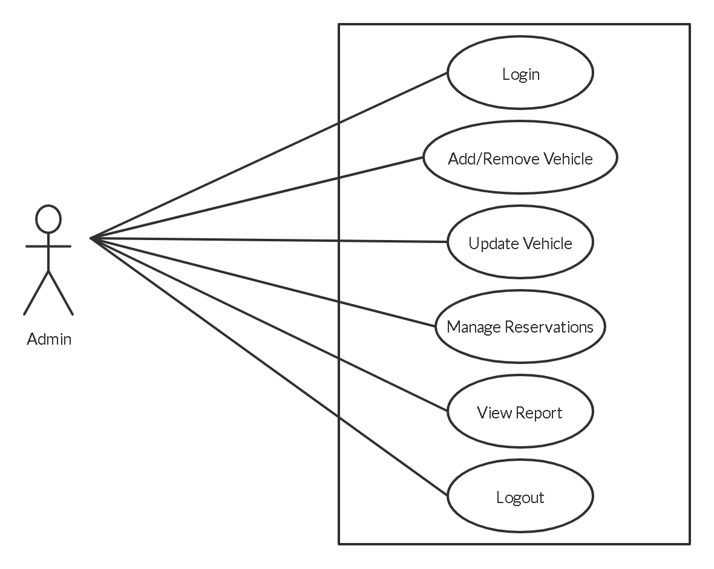

**Fig.3.1. Admin Use Case Diagram**

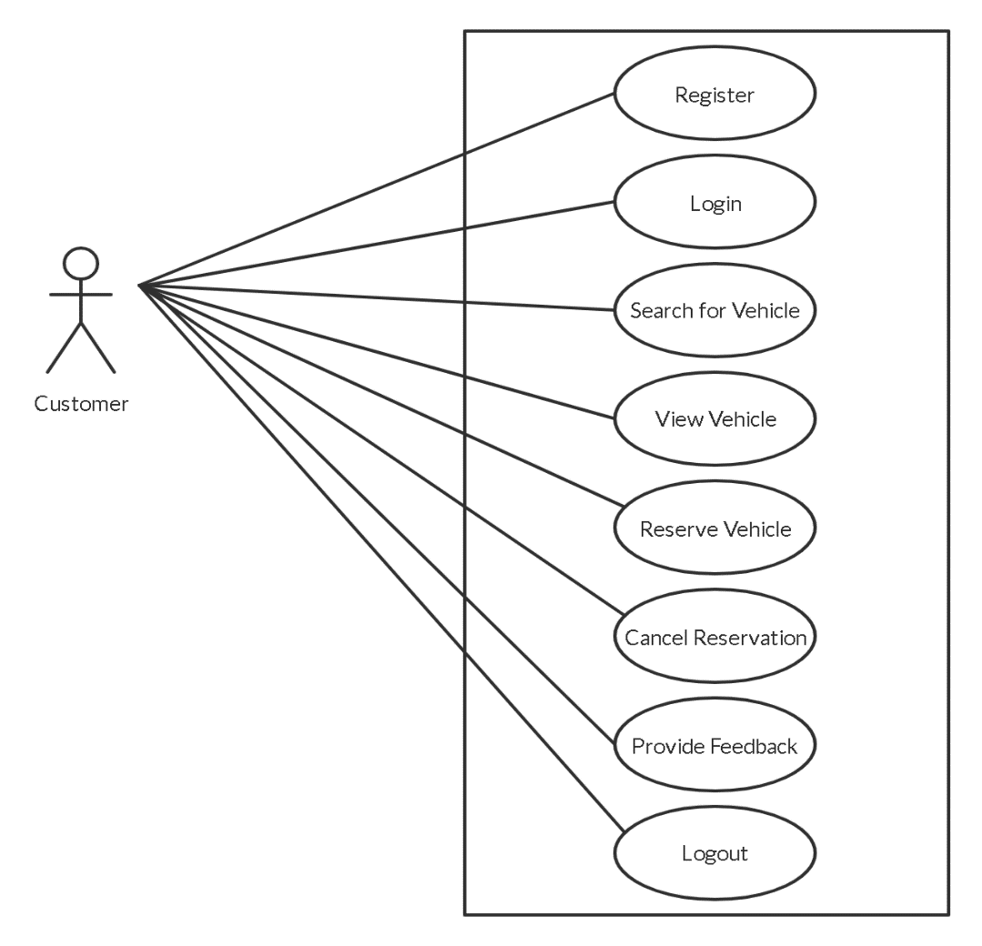

**Fig.3.2. Customer Use Case Diagram.**

**Table 3.1 Use Case – Reserve Vehicle**

|  |  |  |
| --- | --- | --- |
| Use Case 1 | Customer | |
| Goal in Content | Customers would be able to reserve vehicles | |
| Parameters | In: Pickup date, Return date | |
| Preconditions | Successful Login | |
| Post-conditions  (success end) | Successful reservation by customer | |
| Post-conditions  (failure end) | Customer is denied reservation due to wrong reservation details or unavailability of car. | |
| Actors | Customer | |
| Triggers | The desire of the customer to reserve a vehicle. | |
| Description | Action(User) | Response(System) |
| 1. Customer wants to reserve a vehicle. 2. Customer searches for desired vehicle. 3. Customer views details of vehicle. 4. Customer goes ahead to fill reservation info | 1. System accepts entered then sends to the database 2. After the admin has either confirmed/denied, the System shows verdict on customer’s booking page |

**3.3.2.2 Sequence Diagram**

Sequence diagrams also known as “Event diagrams” show the interaction between objects and the order in which the interactions take place (Jain, 2017). They describe how an object functions in a system and the order the functions take place.

Usually, these diagrams are used to model use case scenarios, process logic, and functions on logic, and in the logical view of the program, they are correlated with the use case realization.

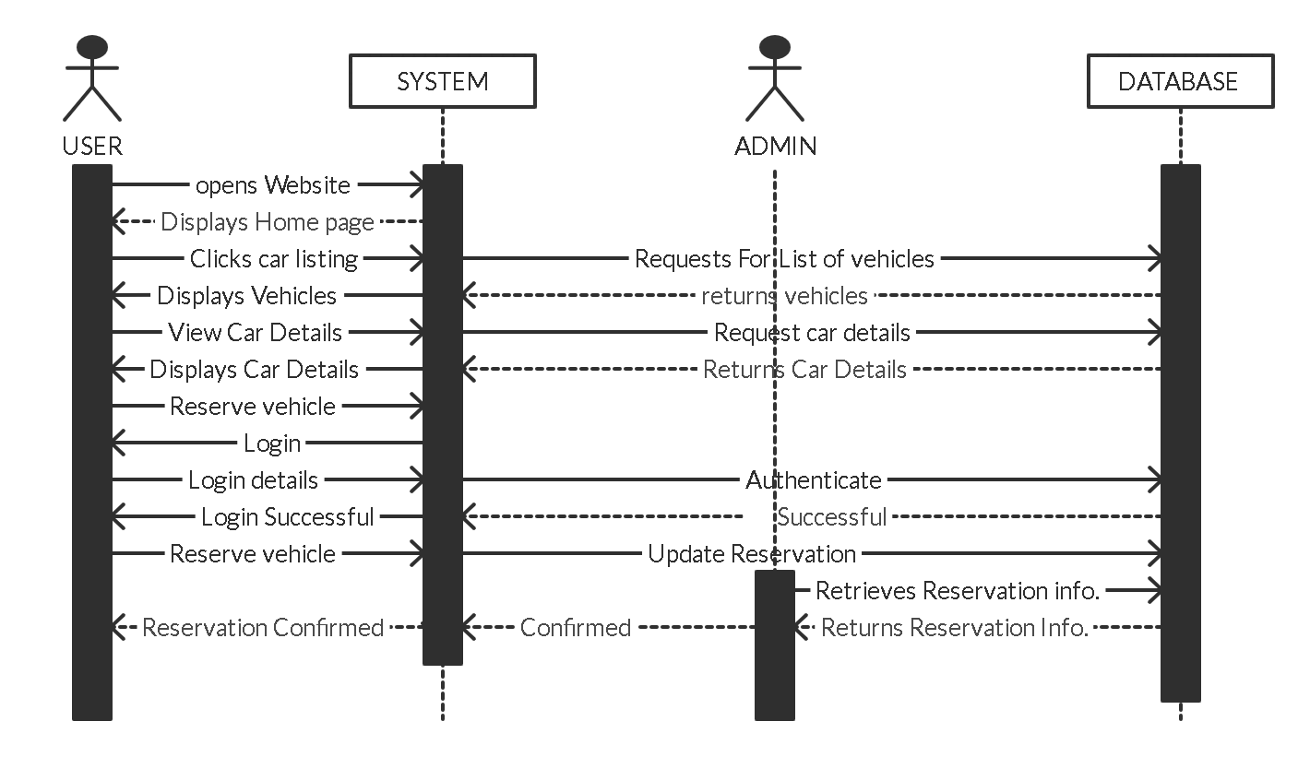

**Fig.3.3. Sequence Diagram – Vehicle Reservation**

**3.3.2.3 Activity Diagram**

Activity diagrams are used to illustrate a system’s flow of control .They are also used to show the steps involved in the execution of a use case. It is concerned with the condition of flow of the system and the sequence in which it happens (Jain, 2017). The Activity diagrams are depicted in Figures 3.4 - 3.6.

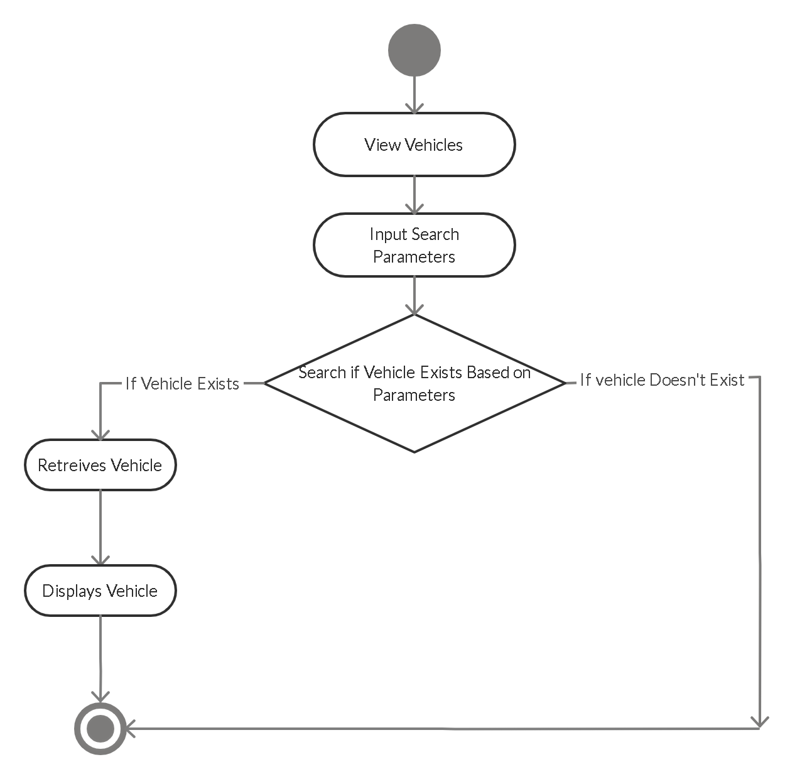

**Fig. 3.4. Activity Diagram – View Vehicle**

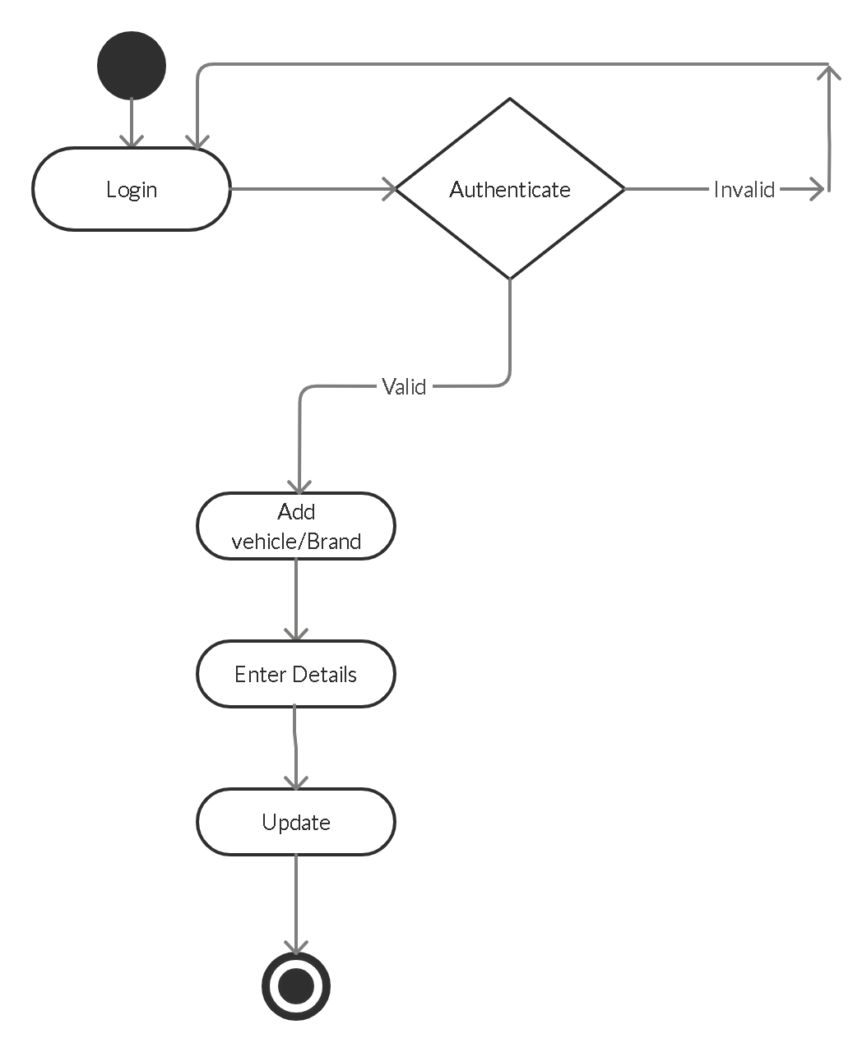

**Fig.3.5. Activity Diagram – Add Vehicle (Admin)**

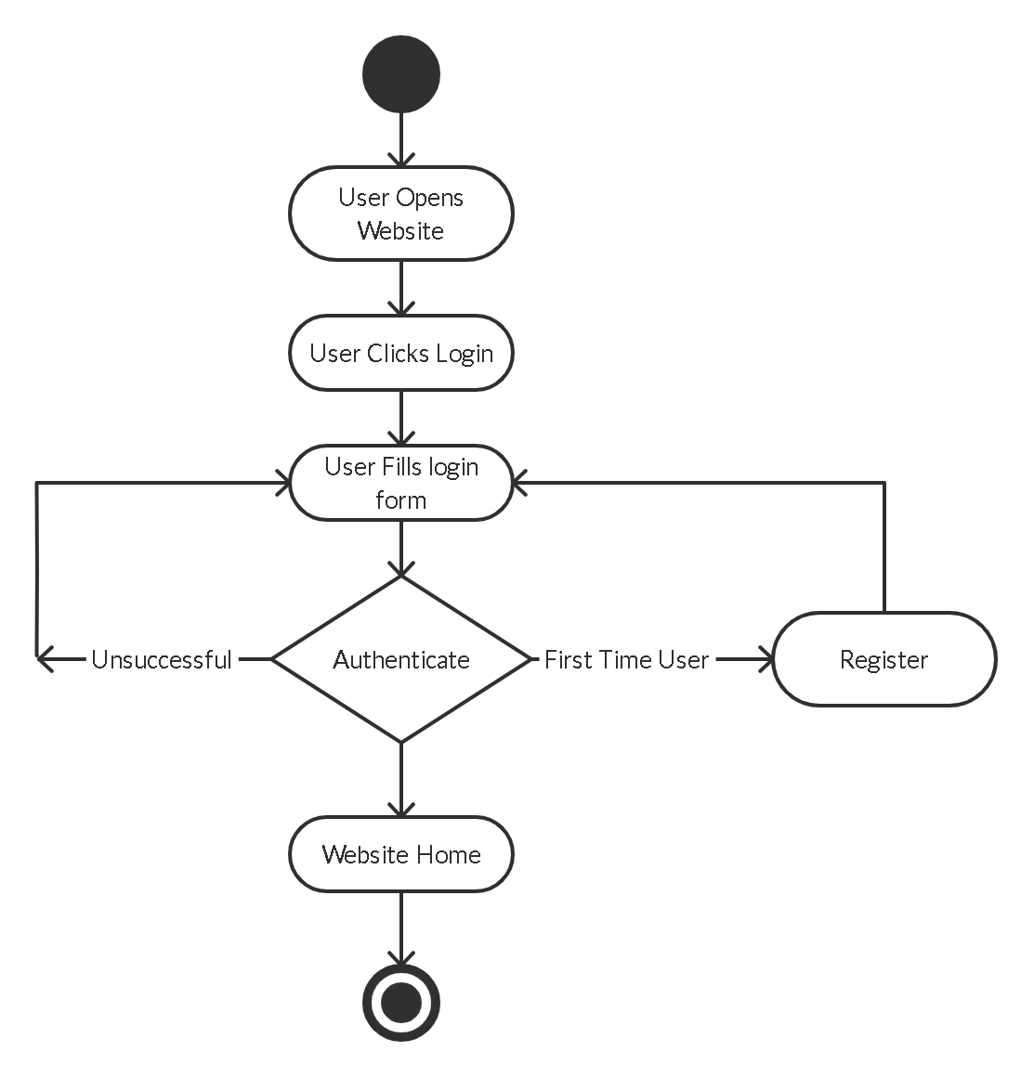

**Fig.3.6. Activity Diagram - User Login**

**3.3.2.4 Class Diagram**

Class diagrams are the building block of all object-oriented systems and the most widely used UML diagram. They show the static structure of a system, showing the classes, the system’s class attributes and methods while also identifying the relationships between the various classes and objects (Jain, 2017).

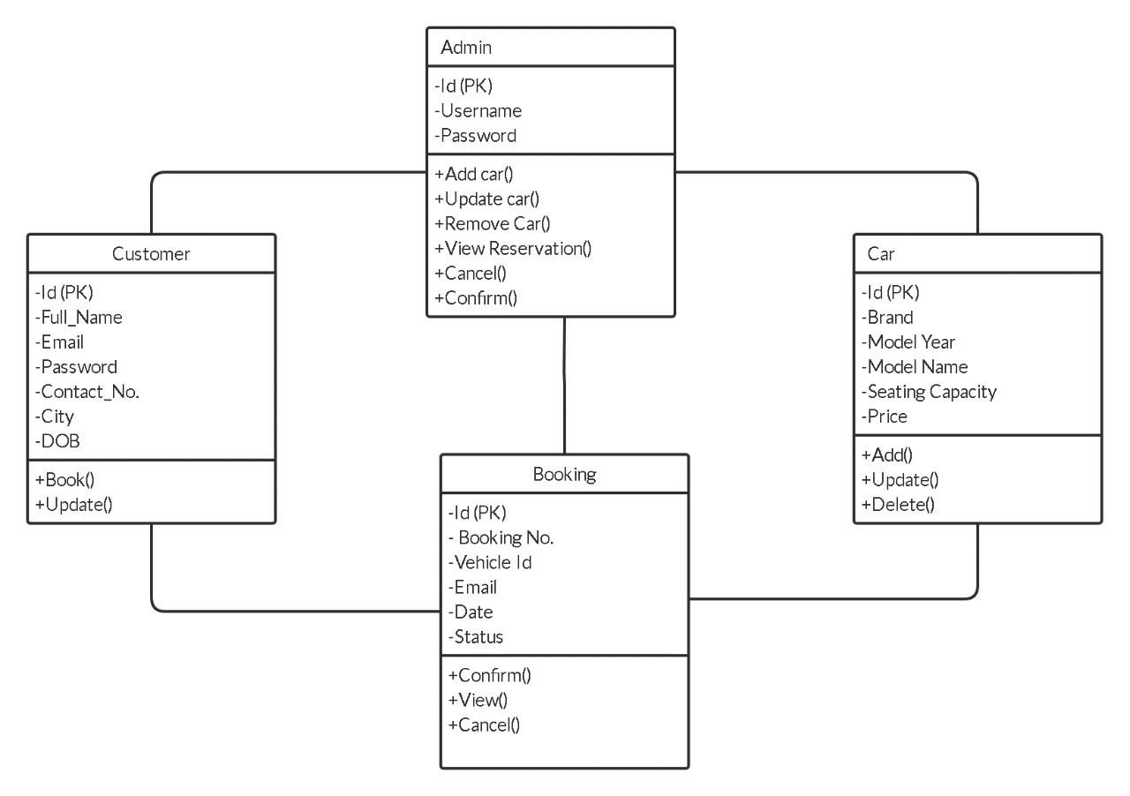

**Fig.3.7. Class Diagram for car rental system**

**3.4 DATABASE DESIGN**

Databases are data structures that stores information in an organized Manner. This enables data to be easily sorted, searched, and updated. Most databases consist of multiple tables, which may each include several different fields (techterms, n.d.).

The three phases of the database design methodology are:

The conceptual design; involves the construction of a model of the information used in an enterprise, independent of all physical considerations.

The logical design; this involves the construction of a model of information used in an enterprise based on a particular data model also independent of other physical considerations.

The Physical design; this entails the database implementation on a secondary storage, describing the base relations, file organizations, and indexes used to achieve efficient access to the data.

**3.4.1. Description of Tables**

The car rental system’s database design consists of some tables described below.

**Table 3.2 Users table**

|  |  |  |  |
| --- | --- | --- | --- |
| NAME | TYPE | NULL | Key |
| Id | int(11) | No | PRIMARY |
| Fullname | varchar(120) | Yes |  |
| Emailid | varchar(100) | Yes |  |
| Password | varchar100) | Yes |  |
| ContactNo | char(11) | Yes |  |
| Dob | varchar(100) | Yes |  |
| Address | varchar(255) | Yes |  |
| City | varchar(100) | Yes |  |
| Country | varchar(100) | Yes |  |
| RegDate | timestamp |  |  |

**Table 3.3 Admin table**

|  |  |  |  |
| --- | --- | --- | --- |
| NAME | TYPE | NULL | Key |
| Id | int(11) | No | PRIMARY |
| UserName | varchar(120) | No |  |
| Password | varchar(100) | No |  |
| UpdationDate | Varchar(20) | No |  |

**Table 3.3 Booking Table**

|  |  |  |  |
| --- | --- | --- | --- |
| NAME | TYPE | NULL | KEY |
| Id | int(11) | No | PRIMARY |
| UserEmail | varchar(100) | Yes |  |
| Vehicleid | int(11) | Yes |  |
| FromDate | varchar(20) | Yes |  |
| ToDate | varchar(20) | Yes |  |
| Message | varchar(255) | Yes |  |
| Status | varchar(11) | Yes |  |
| PostingDate | timestamp | No |  |

**Table 3.4. Vehicle Table**

|  |  |  |  |
| --- | --- | --- | --- |
| NAME | TYPE | NULL | KEY |
| Id | int(11) | No | PRIMARY |
| vehicleTitle | varchar(150) | Yes |  |
| VehicleBrand | int(11) | Yes |  |
| SeatingCapacity | Int(11) | Yes |  |
| Vimage | varchar(120) | Yes |  |
| FuelType | varchar(100) | Yes |  |
| ModelYear | Int(6) | Yes |  |
| PrricePerDay | Int(11) | Yes |  |

**CHAPTER FOUR**

**SYSTEM IMPLEMENTATION**

**4.1 INTRODUCTION**

System implementation is the process of defining the way an information system should be made, it includes ensuring that the information is operational and that system meets quality standard (Millar & Baar, 2017).

This chapter discusses the implementation measures for the developed Car rental system.

**4.2 SYSTEM REQUIREMENTS**

System requirements can be defined as the necessary or minimum configurations a system must have in order to run software or hardware applications efficiently (Techopedia, 2015).

**4.2.1 Hardware Requirements**

The systems requires a strong internet connection in order to quickly load the car catalogue and other media. The minimum requirements for the proposed system are shown in Table 4.1 below.

**Table 4.1. The Hardware Requirements**

|  |
| --- |
| **Minimum Requirements** |
| Minimum of 1GB, Random Access Memory (RAM) |
| Modem or Ethernet Card |
| Minimum 32 Bit Video Graphics Adapter (VGA) |
| Processor: 1.0GHz or Higher processor |
| Hard Disk space: 10 GB (minimum) |
| Computer system with at least Intel Pentium Centrino 500 MHz or compatible |
| Point device (Mouse), Enhanced Keyboard |
| Uninterrupted Power Supply (UPS) |

**4.2.2 Software Requirements**

Software requirements help manage software essentials that should be installed on a PC so as to give an ideal working application. The software requirements of the system is specified in table 4.2. Below.

**Table 4.2. Software Requirements**

|  |  |
| --- | --- |
| **Requirements** | **Software** |
| Operating System | Microsoft Windows Vista, XP, 7, 8, 8.1, 10 |
| Database Management System | MySQL |
| Programming Language | PHP,CSS,HTML |
| Web Servers | XAMPP v3.2.2, Apache HTTP Server, MySQL Server |

**4.3 IMPLEMENTATION TOOLS USED**

Sublime text is the tool used in the development of the website. PHP and Html are the main languages used. PHP is a server-side scripting language which enables seamless communication between the front-end and the database.

MYSQL server and the Apache HTTP server were used through the XAMPP web server, which seamlessly integrates PHP with MYSQL, among other functions.

**4.4 SOFTWARE DEVELOPMENT METHODOLOGY**

The Agile development methodology was the methodology used due to the fact that it embraces change and also the system being web-based may be upgraded in the future making the agile methodology very suitable.

The Agile methodology is an iterative development methodology which focuses on the reduction of documentation and process overheads and on incremental software delivery (Sommerville, 2016). Fig. 4.3. Below shows the agile development process.

Beck et al first described agile principles which have evolved ever since (W3computing, n.d.). The principles can be expressed in a series of sayings:

1. Satisfy the customer through delivery of working software
2. Embrace change, even if introduced late in development
3. Continue to deliver functioning software incrementally and frequently
4. Encourage customers and analysts to work together daily
5. Trust motivated individuals to get the job done
6. Promote face-to-face conversation
7. Concentrate on getting software to work
8. Encourage continuous, regular, and sustainable development
9. Adopt agility with attention to mindful design
10. Support self-organizing teams
11. Provide rapid feedback
12. Encourage quality
13. Review and adjust behavior occasionally, and
14. Adopt simplicity.

3.2 PlanBasedAgile.eps

**Fig. 4.1. Agile Development Process**

**4.5 PROGRAM MODULES AND INTERFACES**

This section describes each module of the application and the various interfaces.

**4.5.1 Login Module**

This module pops up when the customer desires to log into the system by clicking the login/register button. In order for any user to use the core functions of the system, he/she has to log in. The customer needs a valid email and password in order to gain access to the system. Fig 4.1 below is a screenshot of the Login Module.

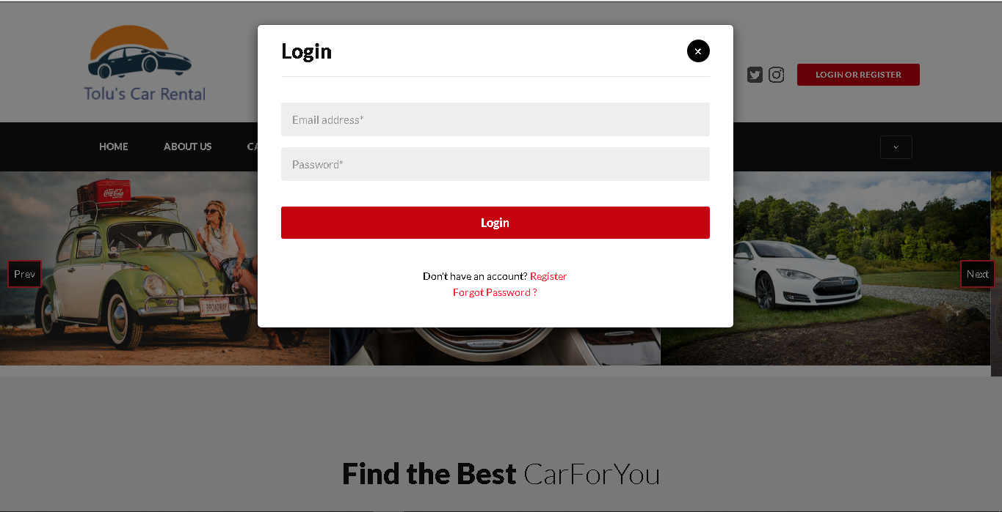

**Fig.4.2 Login Module**

**4.5.2 Registration Module**

This module pops up when the user wants to register as a customer. It consists of a form that the customer is required to fill in order to access the key aspects of the system. Fig. 4.2 below is a screenshot of the Registration Module.

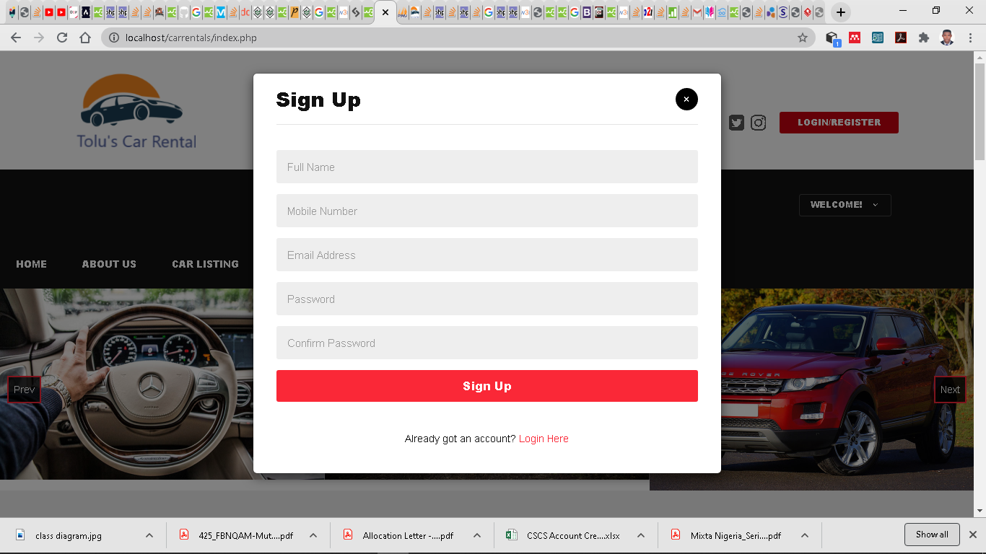

**Fig. 4.3. Registration Module**

**4.5.3 Reservation Page**

Any user can access the reservation page once he/she has searched and clicked on the desirable car, meanwhile before a user can successfully reserve a chosen car, he/she needs to have logged into the system. The customer selects the car and then proceeds to fill in the Pickup date and Return dates before clicking the reserve button. Fig. 4.3 below is a screenshot of the Reservation Page.

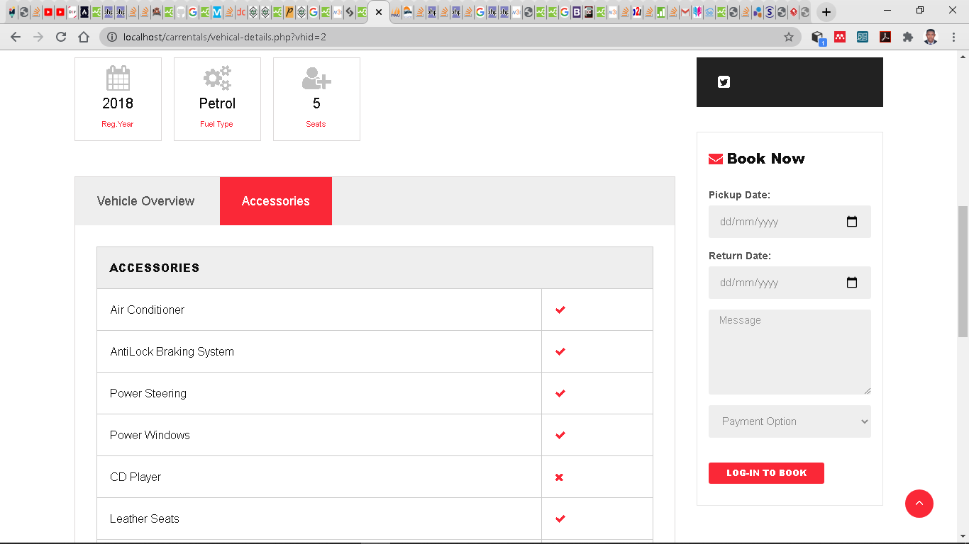

**Fig. 4.4. Reservation Page**

**4.5.4 Home Page**

The first page displayed when the site is opened, it contains various links to the different aspects of the website. Fig. 4.4 below is the screenshot of the system’s Home page.

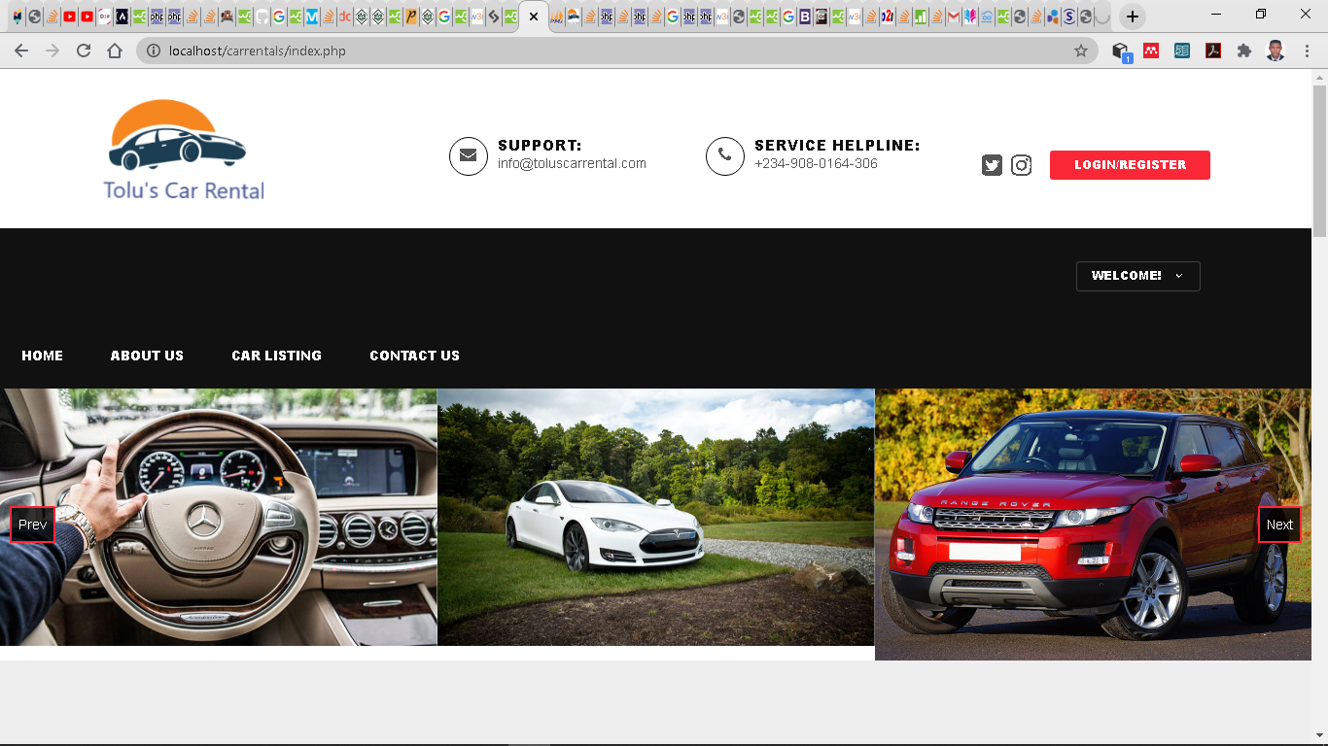

**Fig. 4.5 Home Page**

**4.5.5 System Report (Admin)**

The system’s report contains a summary of all the current activities in the system. It can only be accessible by an admin after he has logged in successfully. The report is embedded in the Admin dashboard and is the first thing the admin sees after logging into the system. Fig. 4.5 below is a screenshot of the admin dashboard containing the system report.

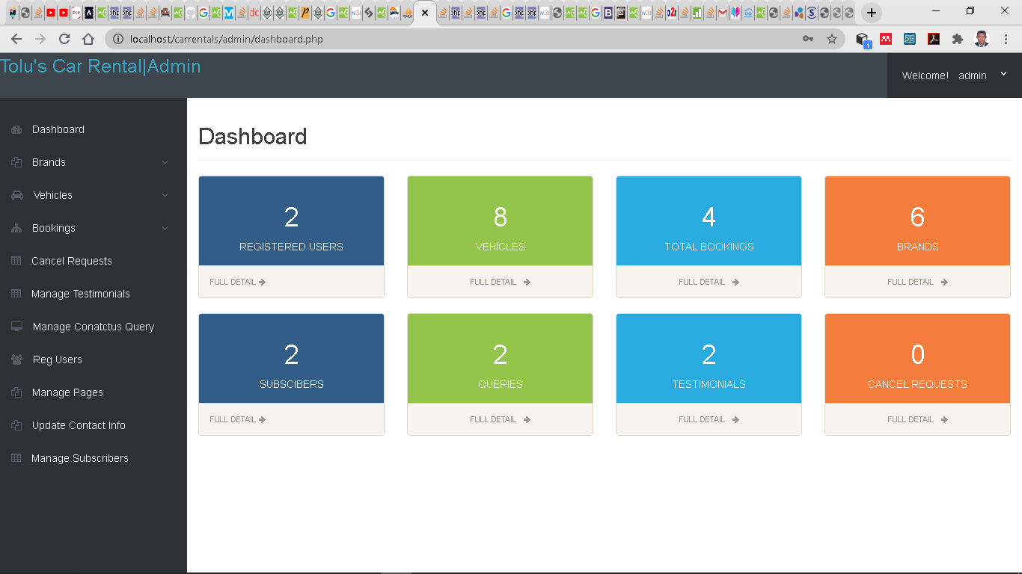**Fig. 4.6. System Report (Admin)**

**4.5.6 Car Listing Page**

The car listing page contains the list of all the available cars for rent. The user has access to the full car catalog and also a search feature, which enables the user to search for a car depending on the search parameters imputed. Once the user has made his choice, he can then view the car's details to ensure it suits his needs. Fig. 4.6 below is a screenshot of the Car listing page. 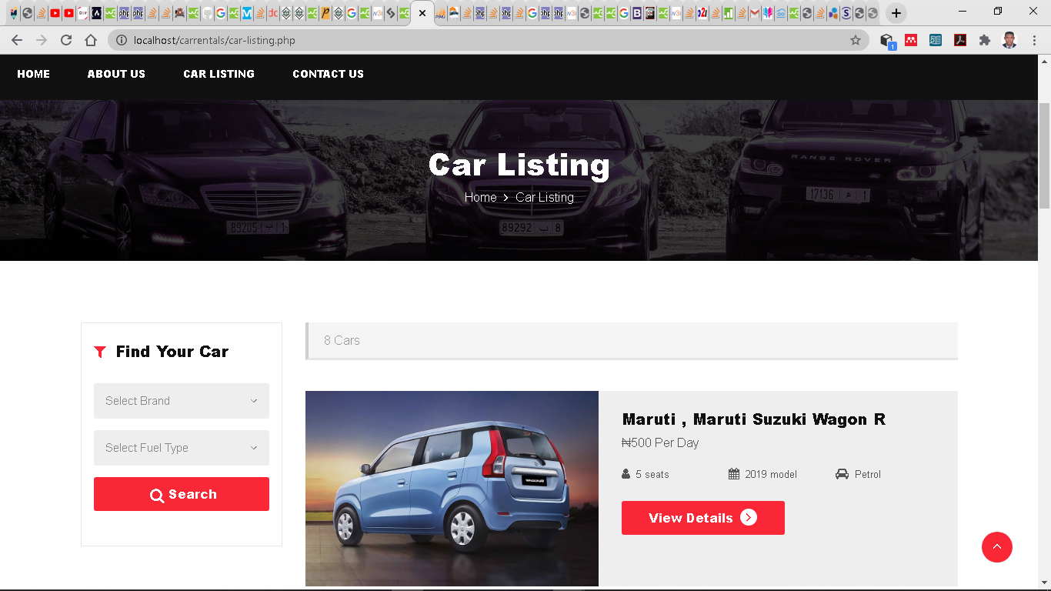

**Fig. 4.7. Car listing page**

**4.5.7 User Profile Page**

This module basically shows the User’s details and also enables the customer edit personal information. All information about a registered customer is displayed on this page. Figure 4.7 below is a screenshot of the User profile.

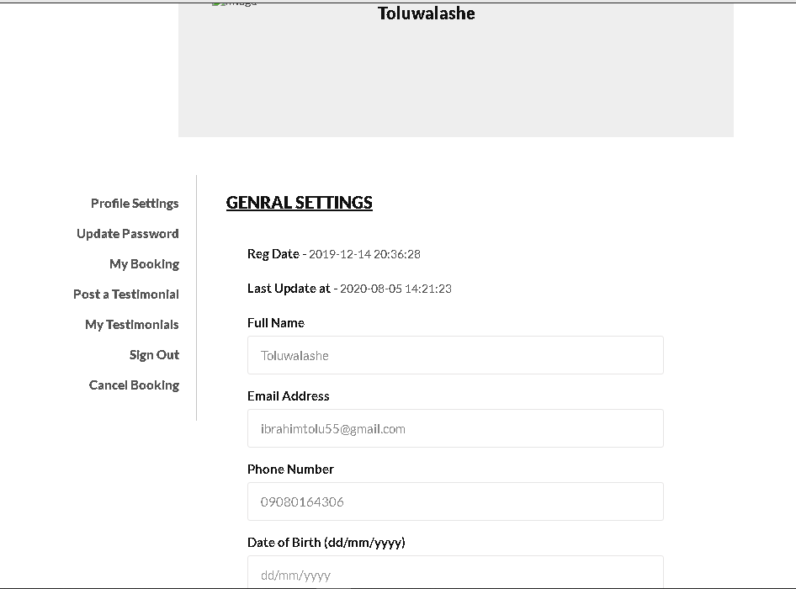**Fig. 4.8 User Profile Page**

**CHAPTER 5**

**SUMMARY, CONCLUSION AND RECOMMENDATION**

**5.1 SUMMARY**

The car rental system is a web-based system, which comprises of different modules. It was design using a user-oriented approach, keeping the interface as simple as possible, however also keeping the company in mind by providing functionalities that would streamline their activities.

The system being web-based can be accessed easily though a browser provided there is an internet connection. The IDE used to develop the system is Sublime text. HTML, PHP, CSS and JavaScript were the languages used while the database used was MYSQL through the XAMPP web server.

The project may not be flawless but its advantages cannot be overemphasized. It will make the renting process way easier for the customer and will also give the company more control over its operations. The system has a special feature whereby the admin can edit the website’s contents right from the comfort of his account, it enables him edit these pages, add , delete and update car without writing any piece of code.

**5.2 CONCLUSION**

Manual processes, although they still end up getting the job done at the end of the day, might prove inefficient in many ways, e.g. wastage of time and resources which can otherwise be done much quickly and more accurately by computer systems while also using less resources. Luckily the growth in technological development over the years has increased and therefore changed the normal way activities are carried out, it has helped breakdown processes, optimize operations and supervise activities.

The reason for the development of the car rental system was to make the car rental process easier for the customers while also streamlining the company’s processes which has been fulfilled and while doing so gave me practical knowledge on the processes involved in the design and implementation of systems and also the computerization of processes.

**5.3 RECOMMENDATIONS**

The system being a web-based car rental system, means it can only be accessed through a web browser with an internet connection. I would recommend that further research should be carried out on the project in order to develop more ways to access the system, e.g. development of mobile apps and also the exploration of SMS technology as a way to also rent cars.

I would also recommend the integration of a credit/debit card payment system into the website to provide wider options for the customer to pay.



**REFERENCES**

Arnold Clark Car and Van Rental (2015). *History of Car Rental: What has changed?* Retrieved from <https://www.arnoldclarkrental.com/latest-news/275-history-of-car-rental-what-has-changed>.

Bourgeois, D. T. (2014). Chapter 1: What Is an Information System? Published through the Open Textbook Challenge by the Saylor Academy.

Cress, K. (2010). *5 Types of Information Systems - MindMeister Mind Map*.

Deepa, Senthilkumar A.V. (2019). Tourism and traveling facility of car rental resource management and information system. International Journal of Computer Science and Mobile Computing (IJCSMC), 8(9), 208 – 214.

History of car rental: what has changed? (n.d.). Retrieved from https://www.arnoldclarkrental.com/latest-news/275-history-of-car-rental-what-has-changed

Essays, UK. (2018). History about Car Rental Companies Marketing Essay. Retrieved from <https://www.ukessays.com/essays/marketing/history-about-car-rental-companies-marketing-essay.php?vref=1>

Components of Information System - GeeksforGeeks. (n.d.). Retrieved from https://www.geeksforgeeks.org/components-of-information-system/

Mirzodaler Muhsinzoda. (2015). Advantages and Disadvantages of Information Systems. *PublicaTIC*, p. 1.

Paul (2011). The History of the Car Rental Industry. Retrieved from <https://www.carrentalexpress.com/blog/history-car-rental-industry>

Picincu, A. (2018). Role of Information Systems in an Organization. Retrieved from <https://bizfluent.com/about-6525978-role-information-systems-organization.html>

Rouse, M. (2015). *IS (information system or information services).* Retrieved from <https://whatis.techtarget.com/definition/IS-information-system-or-information-services>

The Art of Service (2019) *The Six Types Of Information Systems And Their Functions*. Retrieved from <https://theartofservice.com/the-six-types-of-information-systems-and-their-functions.html>

MSG. (2018). Types of Information Systems - Components and Classification of Information Systems. Retrieved from Managementstudyguide website: https://www.managementstudyguide.com/types-of-information-systems.htm;

Online Class Notes (2013). *What is information processing cycle? 4 phases of information processing cycle?* Retrieved from <https://www.onlineclassnotes.com/2017/05/what-is-information-processing-cycle-what-are-the-four-phases-of-information-processing-cycle.html>

V.S.BAGAD. (2008). *Management Information Systems*. Technical Publications Pune.

Wikipedia contributors. (2019). Car rental. In Wikipedia, the Free Encyclopedia. Retrieved 14:00, January26, 2020, from <https://en.wikipedia.org/w/index.php?title=Car_rental&oldid=921415626>

Kendall, K., & Kendall, J. (2002). *Systems analysis and design* (5th Ed.). Upper Saddle River, NJ: Prentice Hall.

Odhiambo, D. (2020). *System Design in Software Development -The Andela Way*. 1–3. Retrieved from <https://medium.com/the-andela-way/system-design-in-software-development-f360ce6fcbb9>

Jain, A. (2017). Unified Modeling Language (UML) | an Introduction - GeeksforGeeks. Retrieved from <https://www.geeksforgeeks.org/unified-modeling-language-uml-introduction/>

Millar, P. S., & Baar, C. (2017). Systems Implementation. In Judicial Administration in Canada (pp. 297–319). https://doi.org/10.2307/j.ctt1w1vn82.18

What are System Requirements? - Definition from Techopedia. (2015). Retrieved from <https://www.techopedia.com/definition/4371/system-requirements>

Sommerville, I. (2016). *Software Engineering: Global Edition, Tenth Edition*. <https://doi.org/10.1136/bmj.1.5802.756-b>

Agile Modeling : Values and Principles of Agile Modeling. (n.d.). Retrieved from https://www.w3computing.com/systemsanalysis/agile-modeling-values-principles-agile-modeling/

Database Definition. (n.d.). Retrieved from <https://techterms.com/definition/database>

Thakur, D. (n.d.). What is Database Design Methodology? Different Phases of Design Methodology. Retrieved 2020, from <https://ecomputernotes.com/database-system/rdbms/phases-of-design-methodology>

Online Car Rental Check-In - Alamo Rent-A-Car. (n.d.). Retrieved from <https://www.alamo.com/en_US/car-rental/checkin.html>

Make a Reservation | Avis Rent a Car. (n.d.). Retrieved from <https://www.avis.com/en/reservation/make-reservation>

Vehicle Hire - Gatatransport. (n.d.). Retrieved from https://gatatransport.com.ng/vehicle-hire/